Assessment Team Report

The Assessment Team comprised of following three members visited the Department of Human Nutrition on October 01, 2012 in order to assess its M.Sc (Hons) degree program:

- Prof. Dr. Saleem Khan Convener AT
- Dr. Ziauddin AT Member
- Ms. Mahpara Safdar AT Member
- Dr. Yasser Durrani External AT Member

The above team in its meeting with the Program team, QEC officials, Dean and Chairman, identified the following Strength and Weaknesses of the program:

Strengths:

- The current teaching staff is well- qualified. Three (03) faculty members are Ph.D holders and rest are pursuing their higher studies i.e. Ph.D.

- The department has one laboratory facility for students.

- The classes are being taught regularly and course contents are completed within the stipulated period.

Weaknesses:

- Lack of Funds for research. The only source is the research projects earned.

- Lack of Support personnel for laboratory.

- Computer laboratory, faculty Offices, Library and well-equipped lecture rooms are required.

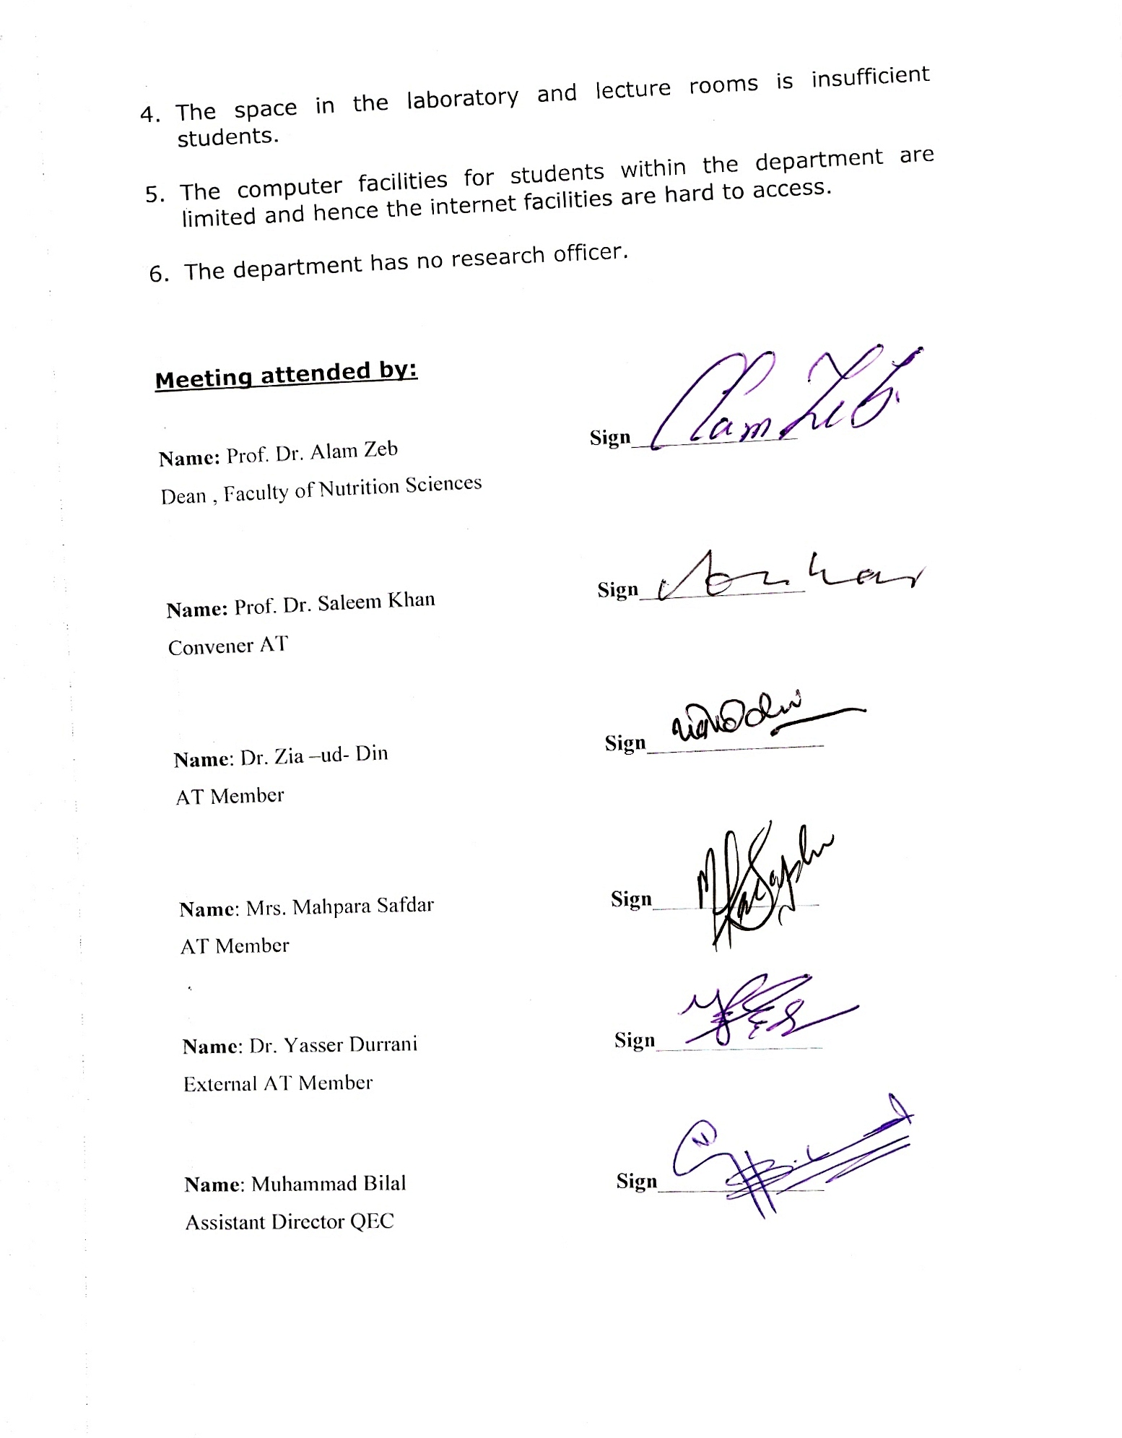

- The space in the laboratory and lecture rooms is insufficient students.

- The computer facilities for students within the department are limited and hence the internet facilities are hard to access.

- The department has no research officer.

Meeting attended by:

Name: Prof. Dr. Alam Zeb Sign_______________
Dean , Faculty of Nutrition Sciences

Name: Prof. Dr. Saleem Khan Sign_______________
Convener AT

Name: Dr. Zia –ud- Din Sign________________
AT Member

Name: Mrs. Mahpara Safdar Sign_______________
AT Member

Name: Dr. Yasser Durrani Sign_______________
External AT Member

Name: Muhammad Bilal Sign_______________
Assistant Director QEC

